TABLE OF CONTENTS
S.No. | Contents | Page No.
1 | Cover Page | —
2 | Certificate | —
3 | Acknowledgement | —
4 | Table of Contents | 1
5 | Abstract | 2
6 | Introduction | 6
7 | System Analysis | 9
8 | Database Design | 11
9 | ER Diagram | 12
10 | Relational Schema | 13
11 | Table Design | 14
12 | Normalization | 16
13 | SQL Implementation | 19
14 | SQL Queries & Screenshots | 22
15 | Conclusion & Future Enhancements | 31
16 | References | 31

ABSTRACT

The Bank Account Management System is designed to manage and organize banking operations through a centralized relational database that provides a structured and efficient approach to storing and handling banking information. The system maintains important details related to banks, branches, employees, customers, accounts, loans, and transactions, allowing related information to be stored in connected tables and retrieved efficiently when required. It provides a systematic way to manage customer details, account information, branch records, employee information, loan details, and transaction records, thereby reducing the difficulties associated with maintaining separate or disconnected banking records. The database uses primary keys, foreign keys, and appropriate constraints to establish relationships between entities, maintain referential integrity, and reduce duplicate or inconsistent data. SQL is used for creating and managing the database, inserting records, retrieving required information, and performing different operations on banking data. The database design is normalized up to Third Normal Form (3NF) to reduce data redundancy and minimize insertion, update, and deletion anomalies. The system also represents different types of bank accounts, including Savings Account and Current Account, within the overall account structure. Through its organized relational design, the system supports bank management, branch management, employee management, customer management, account management, loan management, and transaction management in a consistent manner. Overall, the proposed system provides a structured database foundation that can improve the organization, accessibility, consistency, and efficient management of banking information and can serve as a foundation for extending the system with additional banking services in the future.

LIST OF FIGURES
Figure | Description | Page No.
Figure 1 | ER Diagram of Bank Account Management System | 12
Figure 2 | Bank and Branch Management – SQL Output | 26
Figure 3 | Customer and Account Management – SQL Output | 27
Figure 4 | Loan Management – SQL Output | 30
Figure 5 | Transaction Management – SQL Output | 28

LIST OF TABLES
Table | Table Name | Page No.
Table 1 | Major Database Entities | 11
Table 2 | Bank Table Structure | 14
Table 3 | Branch Table Structure | 14
Table 4 | Employee Table Structure | 14
Table 5 | Customer Table Structure | 14
Table 6 | Account Table Structure | 14
Table 7 | Transaction Table Structure | 14–15
Table 8 | Loan Table Structure | 15
Table 9 | Savings Account Table Structure | 15
Table 10 | Current Account Table Structure | 15
Table 11 | Keys and Constraints | 15

ACRONYMS

- DBMS – Database Management System
- ER – Entity Relationship
- SQL – Structured Query Language
- DDL – Data Definition Language
- DML – Data Manipulation Language
- DQL – Data Query Language
- DCL – Data Control Language
- TCL – Transaction Control Language
- PK – Primary Key
- FK – Foreign Key
- 1NF – First Normal Form
- 2NF – Second Normal Form
- 3NF – Third Normal Form
- IFSC – Indian Financial System Code
- ISA – Is-A Relationship

1. INTRODUCTION

1.1 Brief Information about the Project

The Bank Account Management System is a database application designed to manage and organize banking-related information in a centralized relational database. The system stores information about banks, branches, employees, customers, accounts, loans, and transactions.
The project provides a structured database for maintaining customer details, account information, branch records, employee information, loan details, and transaction records. It also supports different types of accounts, such as Savings Accounts and Current Accounts, through the account specialization represented in the ER diagram.
The system is intended to provide an organized alternative to maintaining banking records through separate or disconnected records. By storing related information in properly connected tables, the database supports consistent data storage, efficient retrieval, and easier management of banking information.
The system uses primary keys and foreign keys to establish relationships between entities and maintain referential integrity. SQL queries can be used to retrieve customer, account, loan, transaction, branch, and employee information from the database.This project demonstrates how a relational database can be designed and implemented to support the basic information-management requirements of a banking environment.

1.2 Motivation and Contribution of Project
The Bank Account Management System is motivated by the need to maintain banking information in a structured and organized manner. Managing bank, branch, customer, account, loan, employee, and transaction details through separate records can lead to duplicate information, difficulty in searching records, and inconsistencies. A centralized relational database provides a systematic approach to storing related banking information and maintaining relationships between different entities through primary and foreign keys.
The major contributions of the project are:
- Centralizing banking records in one relational database.
- Reducing duplicate and inconsistent information.
- Maintaining referential integrity using primary and foreign keys.
- Managing customer and account information efficiently.
- Maintaining branch and employee details.
- Supporting loan and transaction management.
- Managing different account types such as Savings Account and Current Account.
- Supporting SQL-based retrieval and reporting of banking information.

1.3 Objectives of the Project
- To develop a centralized database for managing banking information.
- To maintain bank and branch details systematically.
- To store and manage employee information.
- To maintain customer records and their account details.
- To manage different types of accounts, including Savings and Current Accounts.
- To maintain loan information associated with customers and branches.
- To record and manage banking transactions.
- To reduce data redundancy and update anomalies.
- To maintain data integrity using primary keys and foreign keys.
- To support efficient retrieval of banking information using SQL queries.
- To provide a structured database foundation for banking operations.

1.4 Scope of the Project
The scope of the Bank Account Management System covers the database-oriented management of banking information through a centralized relational database. The core scope includes bank, branch, employee, customer, account, loan, and transaction data, providing a structured platform for storing, organizing, and managing important banking records. The system supports the maintenance of customer details, account information, branch records, employee information, loan details, and transaction records, making it easier to retrieve and manage related information when required. It also supports different types of accounts, such as Savings Accounts and Current Accounts, through the account structure defined in the database. The database uses primary keys and foreign keys to establish relationships between related entities and maintain data consistency, while SQL queries support efficient storage, retrieval, and reporting of banking information. The system can be used as a database backend for a banking management application and provides a foundation for handling basic banking information and transaction-related operations in an organized manner. The scope can be extended in the future by adding features such as online banking, fund transfers, ATM services, detailed transaction reporting, mobile banking, backup and recovery, and other banking-related services, without changing the basic relational database structure. This makes the system suitable as a foundation for developing a more comprehensive banking management application
2. SYSTEM ANALYSIS

2.1 Existing System
- Manual maintenance of bank and customer records.
- Separate records for customer, account, loan, and transaction information.
- Duplicate records and inconsistent information.
- Time-consuming searching and updating of banking records.
- Difficulty in maintaining related banking information.
- Difficulty in generating consolidated reports.
- Higher possibility of data-entry and record-management errors.

2.2 Proposed System
The proposed Bank Account Management System uses a centralized relational database to organize and manage banking information. It connects related information about banks, branches, employees, customers, accounts, loans, and transactions through properly defined relationships.The system uses primary keys, foreign keys, NOT NULL conditions, UNIQUE constraints, and appropriate CHECK constraints to maintain data integrity and consistency. It also supports different account types, such as Savings Account and Current Account.
- Centralized banking database
- Bank and branch management
- Employee management
- Customer management
- Account management
- Loan management
- Transaction management
- Savings and Current Account management
- SQL-based reporting
- Referential integrity

2.3 Functional Requirements
Module | Functional Requirement
Bank Management | Store and maintain bank information.
Branch Management | Store and maintain branch information associated with the bank.
Employee Management | Store employee details and maintain employee information.
Customer Management | Add, update, search, and display customer details.
Account Management | Store and maintain customer account information.
Loan Management | Store and maintain loan details associated with customers.
Transaction Management | Record and maintain transaction details related to accounts.
Search and Reporting | Retrieve bank, branch, customer, account, loan, and transaction information using SQL queries.

2.4 Non-Functional Requirements
- Performance – Queries should return banking records efficiently for normal database workloads.
- Integrity – Invalid references and duplicate key values should be prevented.
- Security – Database access and privileges should be controlled for authorized users.
- Usability – Forms, database operations, and reports should be understandable to users.
- Reliability – Database operations should maintain a consistent and reliable database state.
- Scalability – The database design should support growth in customers, accounts, transactions, loans, and other banking records.

2.5 Requirements Specification
Category | Suggested Requirement
Hardware | Intel i3 or above; 4 GB RAM minimum; adequate storage; standard display and keyboard/mouse.
Operating System | Windows 10/11 or an equivalent supported platform.
Database | Oracle Database or another relational DBMS used by the implementation.

3. DATABASE DESIGN

3.1 Major Entities
Entity | Description
Bank | Stores information about the bank.
Branch | Stores branch details associated with the bank.
Employee | Maintains information about employees working in the bank branches.
Customer | Stores customer personal and contact information.
Account | Maintains customer bank account information.
Transaction | Records financial transactions associated with accounts.
Loan | Stores loan information associated with customers.
Savings Account | Represents savings-type account information.
Current Account | Represents current-type account information.

3.2 ER Model
The Entity-Relationship (ER) model represents the major entities of the Bank Account Management System and the relationships among them. The model includes entities such as Bank, Branch, Employee, Customer, Account, Transaction, Loan, Savings Account, and Current Account. Each entity represents a specific type of banking information that needs to be stored and managed in the database.
Primary keys are used to uniquely identify the records of each entity, while foreign keys establish relationships between related entities. These relationships help maintain consistency and allow related banking information to be connected efficiently.
The ER model provides a clear conceptual representation of the database structure and shows how different banking entities interact with each other. It serves as the foundation for converting the conceptual design into relational tables during database implementation.

3.3 Relationships
Relationship | Description
Bank→ Branch | A bank can have multiple branches, while each branch belongs to a bank.
Branch → Employee | A branch can have multiple employees who manage banking activities.
Customer→ Account | A customer can have one or more bank accounts.
Account → Transaction | An account can have multiple transactions, such as deposits and withdrawals.
Customer → Loan | A customer can have loan information associated with their banking records.
Account → Savings Account | A savings account represents a specific type of bank account.
Account → Current Account | A current account represents another type of bank account.

4. ER DIAGRAM
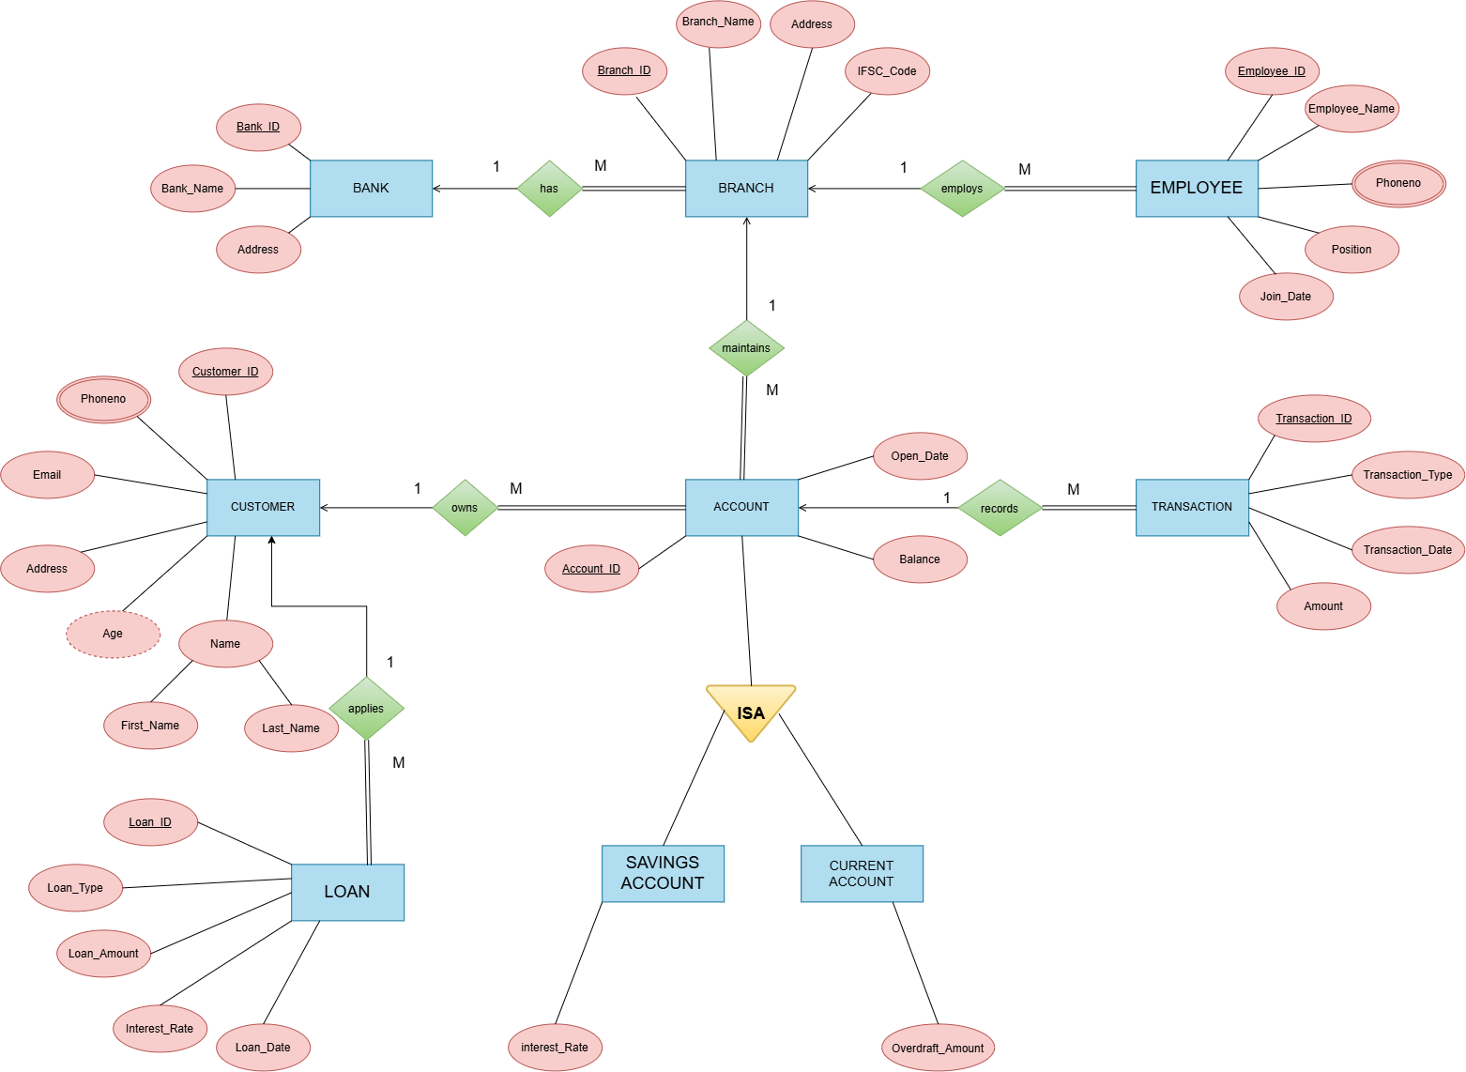

Figure 1: ER Diagram of Bank Account Management System
The ER diagram represents the conceptual structure of the Bank Account Management System. It shows the major entities, their attributes, and the relationships between them. Primary keys and foreign keys are used to identify records and establish connections between related entities. The diagram provides a clear overview of how the different banking entities are organized and connected within the database.
5. RELATIONAL SCHEMA
Relation | Relational Schema
BANK | Bank_ID PK, Bank_Name, Address, Contact
BRANCH | Branch_ID PK, Branch_Name, Address, Bank_ID FK
EMPLOYEE | Employee_ID PK, Name, Phone, Branch_ID FK
CUSTOMER | Customer_ID PK, Name, Phone, Address, Email
ACCOUNT | Account_ID PK, Account_Type, Balance, Open_Date, Customer_ID FK
TRANSACTION | Transaction_ID PK, Account_ID FK, Type, Amount, Transaction_Date
LOAN | Loan_ID PK, Customer_ID FK, Loan_Type, Amount, Loan_Date
SAVINGS ACCOUNT | Account_ID PK/FK, Interest_Rate
CURRENT ACCOUNT | Account_ID PK/FK, Overdraft_Amount

The relational schema represents the database structure of the Bank Account Management System in the form of relational tables. Each relation contains attributes that describe the corresponding entity. Primary keys are used to uniquely identify records, while foreign keys establish relationships between related tables.

6. TABLE DESIGN

6.1 Bank Table
Attribute | Data Type | Constraint | Description
Bank_ID | INT | PK, NOT NULL | Unique bank identifier
Bank_Name | VARCHAR | NOT NULL | Name of the bank
Address | VARCHAR | — | Bank address
Contact | VARCHAR | — | Bank contact information

6.2 Branch Table
Attribute | Data Type | Constraint | Description
Branch_ID | INT | PK | Unique branch identifier
Branch_Name | VARCHAR | NOT NULL | Name of the branch
Address | VARCHAR | — | Branch address
Bank_ID | INT | FK | References Bank

6.3 Employee Table
Attribute | Data Type | Constraint | Description
Employee_ID | INT | PK, NOT NULL | Unique employee identifier
Name | VARCHAR | NOT NULL | Faculty name
Phone | VARCHAR | — | Employee contact number
Branch_ID | INT | FK | References Branch

6.4 Customer Table
Attribute | Data Type | Constraint | Description
Customer_ID | INT | PK, NOT NULL | Unique customer identifier
Name | VARCHAR | NOT NULL | Name of the customer
Phone | VARCHAR | — | Customer contact number
Address | VARCHAR | — | Customer address
Email | VARCHAR | UNIQUE | Customer email address

6.5 Account Table
Attribute | Data Type | Constraint | Description
Account_ID | INT | PK,NOT NULL | Unique account identifier
Account_Type | VARCHAR | — | Type of the bank account
Balance | INT | — | Current account balance
Open_Date | DATE | — | Date on which the account was opened
Customer_ID | INT | — | References Customer

6.6 Transaction Table
Attribute | Data Type | Constraint | Description
Transaction_ID | INT | PK,NOT NULL | Unique transaction identifier
Account_ID | INT | FK | References Account
Type | VARCHAR | — | Type of transaction
Amount | DECIMAL | — | Transaction amount
Transaction_Date | DATE | — | Date of the transaction

6.7 Loan Table
Attribute | Data Type | Constraint | Description
Loan_ID | INT | PK,NOT NULL | Unique loan identifier
Customer_ID | INT | FK | References Customer
Loan_Type | VARCHAR | — | Type of loan
Amount | DECIMAL | — | Loan amount
Loan_Date | DATE | — | Date of loan

6.7 Savings Account Table
Attribute | Data Type | Constraint | Description
Account_ID | INT | PK,FK | Identifies the associated account
Interest_Rate | DECIMAL | — | Interest rate applicable to the savings account

6.7 Savings Account Table
Attribute | Data Type | Constraint | Description
Account_ID | INT | PK,FK | Identifies the associated account
Overdraft_Amount | DECIMAL | — | Maximum overdraft amount allowed for the current account

6.7 Keys and Constraints
Constraint Type | Applied To / Purpose
Primary Key | Bank_ID, Branch_ID, Employee_ID, Customer_ID, Account_ID, Transaction_ID, Loan_ID
Foreign Key | Branch.Bank_ID; Employee.Branch_ID; Account.Customer_ID; Transaction.Account_ID; Loan.Customer_ID; Savings_Account.Account_ID; Current_Account.Account_ID
NOT NULL | Used for important attributes such as IDs, names, and other mandatory values.
UNIQUE | Can be applied to fields such as customer email and other values that must not be duplicated.
CHECK | Can be used to restrict values such as transaction amount, balance, and other valid numeric values.
DEFAULT | Can be used where an appropriate default value is required for selected attributes.

7. NORMALIZATION
Normalization is the process of organizing data into related tables to reduce data redundancy and avoid update, insertion, and deletion anomalies. In the Bank Account Management System, normalization helps separate customer, account, transaction, branch, employee, and loan information into appropriate relations.
The database design is organized to maintain data consistency and establish relationships through primary keys and foreign keys. The normalization process can be described through Unnormalized Form (UNF), First Normal Form (1NF), Second Normal Form (2NF), and Third Normal Form (3NF), following the structure of the sample document.

7.1 Unnormalized Form (UNF)

A single banking record might contain Customer_ID, Customer_Name, Account_ID, Account_Type, Balance, Transaction_ID, Transaction_Type, Transaction_Amount, Branch_ID, and Loan_ID together. Repeating transaction details and repeated customer or branch information can create data redundancy and make the records difficult to maintain.

7.2 First Normal Form (1NF)

In 1NF, repeating groups are removed and each attribute contains a single atomic value. Each customer account and transaction is represented as a separate record, while related banking information is organized into individual fields.
Account_ID | Customer_ID | Balance | Transaction_ID | Transaction_Type | Amount | Transaction_Date
501 | 401 | 50000 | 601 | Deposit | 10000 | 10-01-2022
502 | 402 | 75000 | 602 | Withdrawal | 5000 | 15-02-2022
503 | 403 | 62000 | 603 | Deposit | 15000 | 20-03-2022
504 | 404 | 90000 | 604 | Transfer | 8000 | 05-04-2022
505 | 405 | 45000 | 605 | Deposit | 12000 | 12-05-2022

7.3 Second Normal Form (2NF)
In 2NF, partial dependencies on a composite key are removed. Customer-specific attributes depend on Customer_ID, account-specific attributes depend on Account_ID, and transaction-specific attributes depend on Transaction_ID.These dependencies are separated into individual Customer, Account, and Transaction relations, while maintaining the required foreign key relationships between them. This helps reduce repeated information and improves the consistency and organization of the banking data.
Account Table
Account_ID | Customer_ID | Balance
501 | 401 | 50000
502 | 402 | 75000
503 | 403 | 62000
504 | 404 | 90000
505 | 405 | 45000

Transaction Table
Transaction_ID | Account_ID | Transaction_Type | Amount | Transaction_Date
601 | 501 | Deposit | 10000 | 10-01-2022
602 | 502 | Withdrawal | 5000 | 15-02-2022
603 | 503 | Deposit | 15000 | 20-03-2022
604 | 504 | Transfer | 8000 | 05-04-2022
605 | 505 | Deposit | 12000 | 12-05-2022

7.4 Third Normal Form (3NF)

In 3NF, transitive dependencies are removed so that non-key attributes depend only on the primary key of their respective table. Bank and branch details are stored separately, while customer, account, transaction, employee, and loan information are maintained in their related tables.
This separation reduces data redundancy and update anomalies and helps maintain consistency between related banking records.

Table 1: Account
Account_ID | Customer_ID | Balance
501 | 401 | 50000
502 | 402 | 75000
503 | 403 | 62000
504 | 404 | 90000
505 | 405 | 45000
Table 2: Transaction
Transaction_ID | Account_ID | Transaction_Type | Amount | Transaction_Date
601 | 501 | Deposit | 10000 | 10-01-2022
602 | 502 | Withdrawal | 5000 | 15-02-2022
603 | 503 | Deposit | 15000 | 20-03-2022
604 | 504 | Transfer | 8000 | 05-04-2022
605 | 505 | Deposit | 12000 | 12-05-2022

8. SQL IMPLEMENTATION

8.1 DDL – Data Definition Language
The following DDL is a documentation-ready implementation aligned with the supplied relational schema. Data types may be adjusted to the specific DBMS used by the student team.
Create table Bank(Bank_ID integer,
Bank_Name varchar2(20),
Address varchar2(20),
constraint pk_Bank primary key(Bank_ID));

Create table Branch(
Branch_ID integer,
Branch_Name varchar2(20),
Address varchar2(20),
IFSC_Code varchar2(20),
Bank_ID integer,
constraint pk_Branch primary key(Branch_ID),
constraint fk_Bank_Branch foreign key(Bank_ID)
references Bank(Bank_ID));

Create table Employee(Employee_ID integer,
Employee_Name varchar2(20),
Phoneno integer,
Position varchar2(20),
Salary integer,
Join_Date date,
Branch_ID integer,
constraint pk_Employee primary key(Employee_ID),
constraint fk_Branch_Employee foreign key(Branch_ID)
references Branch(Branch_ID));

Create table Customer(Customer_ID integer,
Phoneno integer,
Email varchar2(20),
Address varchar2(20),
Age integer,
First_Name varchar2(20),
Last_Name varchar2(20),
constraint pk_Customer primary key(Customer_ID));

Create table Account(Account_ID integer,
Open_Date date,
Balance integer,
Branch_ID integer,
Customer_ID integer,
constraint pk_Account primary key(Account_ID),
constraint fk_Branch_Account foreign key(Branch_ID)
references Branch(Branch_ID),
constraint fk_Customer_Account foreign key(Customer_ID)
references Customer(Customer_ID));

Create table Transaction(Transaction_ID integer,

Transaction_Type varchar2(20),

Transaction_Date date,

Amount integer,

Account_ID integer,

constraint pk_Transaction primary key(Transaction_ID),

constraint fk_Account_Transaction foreign key(Account_ID)

references Account(Account_ID));

Create table Loan(Loan_ID integer,
Loan_Type varchar2(20),
Loan_Amount integer,
Interest_Rate integer,
Loan_Date date,
Transaction_ID integer,
constraint pk_Loan primary key(Loan_ID),
constraint fk_Transaction_Loan foreign
key(Transaction_ID)
references Transaction(Transaction_ID));

Create table Savings_Account(Interest_Rate integer,
Account_ID integer,
constraint pk_Account primary key(Account_ID),
constraint fk_Account_Savings_Account foreign
key(Account_ID)
references Account(Account_ID));

Create table Current_Account(Overdraft_Amount integer,
Account_ID integer,
constraint pk_Current_Account primary key(Account_ID),
constraint fk_Account_Current_Account foreign
key(Account_ID)
references Account(Account_ID));

8.2 DML – Data Manipulation Language
INSERT INTO Bank VALUES (101,'State Bank','Machilipatnam');
INSERT INTO Branch(Branch_ID, Branch_Name, Address, IFSC_Code, Bank_ID)
VALUES(201,'State Bank Branch','Machilipatnam','SBIN000201',101);
INSERT INTO Employee(Employee_ID, Employee_Name, Phoneno, Position, Salary, Join_Date, Branch_ID)
VALUES(301,'Ravi Kumar',9876500001,'Manager',55000,
TO_DATE('15-02-2021','DD-MM-YYYY'),201);
INSERT INTO Customer(Customer_ID, Phoneno, Email, Address, Age, First_Name, Last_Name)
VALUES(401,9949785030,'ramesh@gmail.com','Machilipatnam',
35,'Ramesh','Kumar');
INSERT INTO Account(Account_ID, Open_Date, Balance, Branch_ID, Customer_ID)
VALUES(501,TO_DATE('10-01-2021','DD-MM-YYYY'),50000,201,401);
INSERT INTO Transaction(Transaction_ID, Transaction_Type, Transaction_Date, Amount, Account_ID)
VALUES(601,'Deposit',TO_DATE('10-01-2022','DD-MM-YYYY'),10000,501);
INSERT INTO Loan(Loan_ID, Loan_Type, Loan_Amount, Interest_Rate, Loan_Date, Transaction_ID)
VALUES(701,'Home Loan',500000,7,
TO_DATE('10-01-2022','DD-MM-YYYY'),601);

8.3 DQL – Data Query Language
SELECT * FROM Bank;
SELECT Account_ID, Balance, Customer_ID
FROM Account
WHERE Balance > 50000;
SELECT Employee_ID, Employee_Name, Position, Salary
FROM Employee
ORDER BY Salary DESC;
SELECT b.Bank_Name, br.Branch_Name
FROM Bank b
JOIN Branch br ON b.Bank_ID = br.Bank_ID;
SELECT c.First_Name, c.Last_Name, t.Transaction_Type, t.Amount FROM Customer c
JOIN Account a ON c.Customer_ID = a.Customer_ID
JOIN Transaction t ON a.Account_ID = t.Account_ID;
9. SQL QUERIES & SCREENSHOTS
The following query set is prepared to satisfy the documentation requirement for a 30–40 query SQL section. The examples cover selection, filtering, joins, aggregation, subqueries, updates, deletion, and reporting. Exact outputs depend on the records inserted in the final project database.
Q1. Display all branches
select * from branch;
Output:
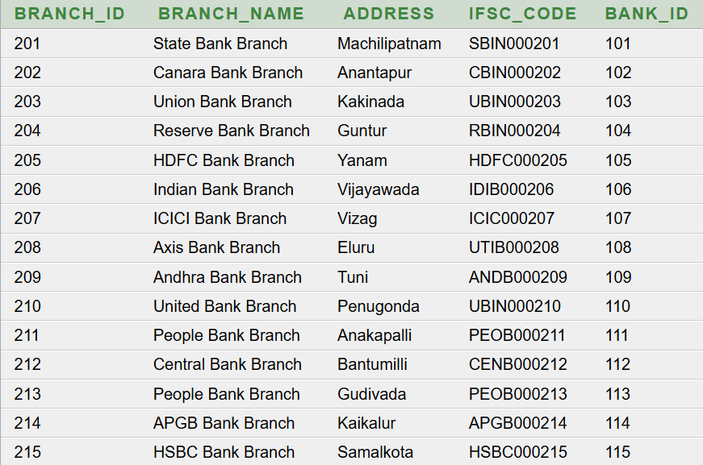

Q2. Display all customers
select * from Customer;
Output:
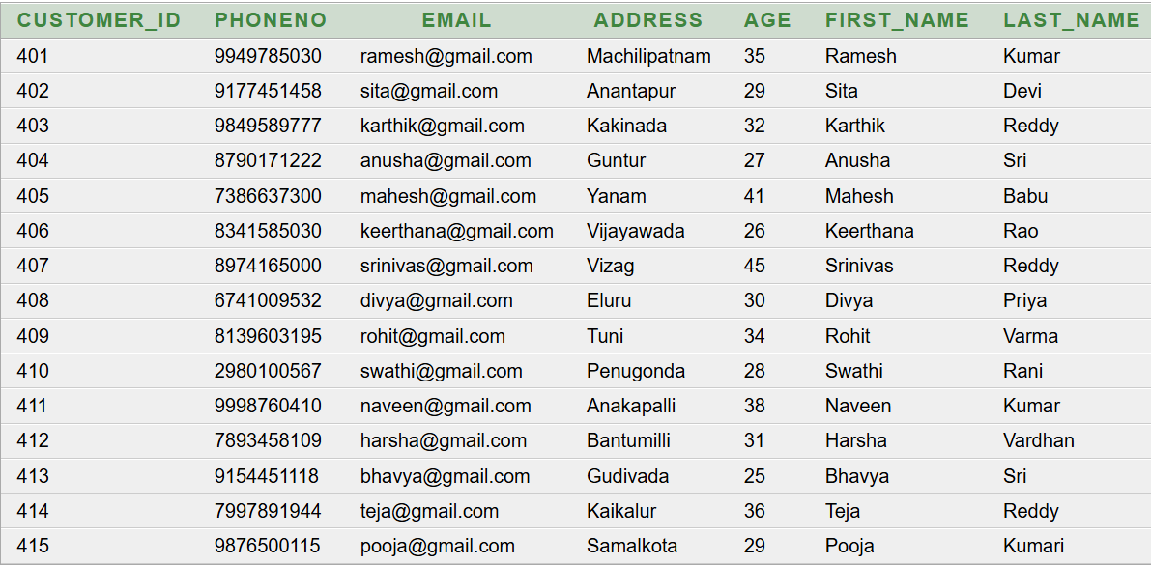

Q3. Display accounts having balance greater than 50000
select account_id, balance
from account
where balance > 50000;
Output:
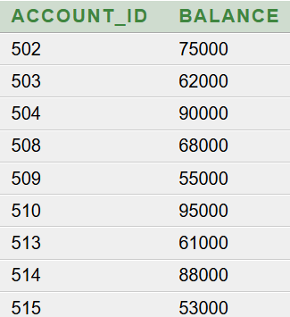

Q4. Count the total number of customers
select count(*) as total_customers
from customer;
Output:


Q5. Find the maximum account balance
select max(balance) as maximum_balance
from account;
Output:
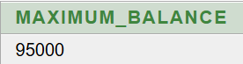

Q6. Find the average salary of employees
select avg(salary) as average_salary
from employee;
Output:
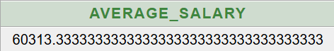

Q7. Display customers whose age is greater than 30
select customer_id, first_name, last_name, age
from customer
where age > 30;
Output:
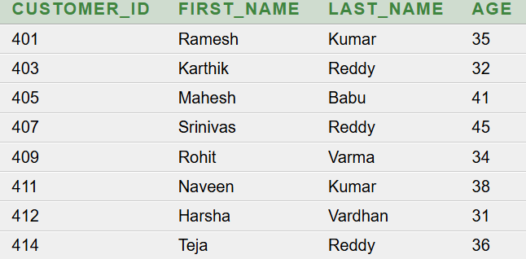

Q8. Display all deposit transactions
select transaction_id, transaction_date, amount, account_id from transaction
where transaction_type = 'Deposit';
Output:
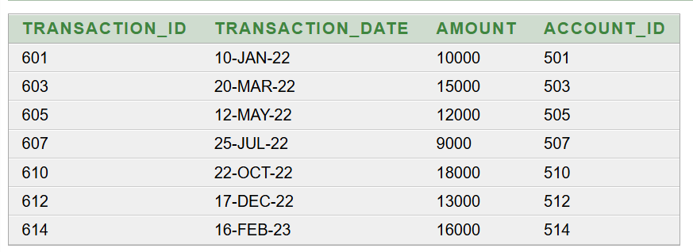

Q9. Display bank names along with their branch names
select b.bank_name, br.branch_name from bank b, branch br
where b.bank_id = br.bank_id;
Output:
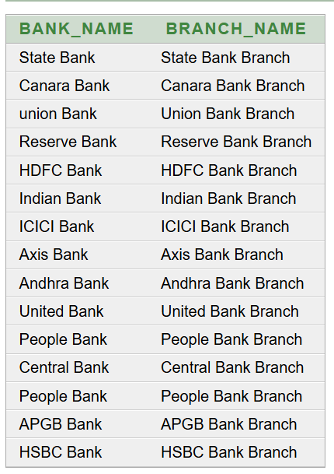

Q10. Display employee names along with their branch names
select e.employee_name, e.position, br.branch_name from employee e, branch br
where e.branch_id = br.branch_id;
Output:
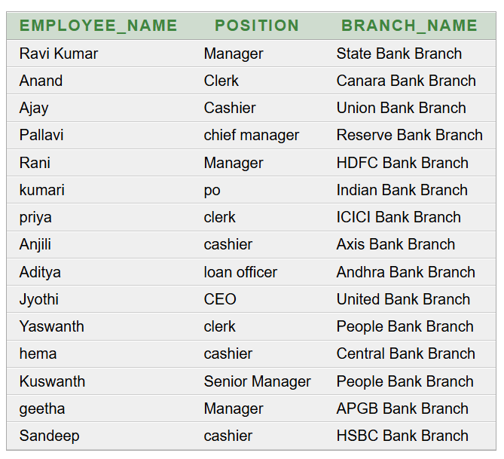
Q11. Find the total transaction amount for each transaction type
select transaction_type, sum(amount) as total_amount from transaction
group by transaction_type;
Output:
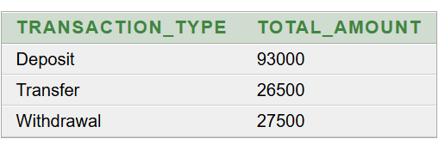
Q12. Display customer names along with their account details
select c.first_name, c.last_name, a.account_id, a.balance from customer c,account a
where c.customer_id = a.customer_id;
Output:
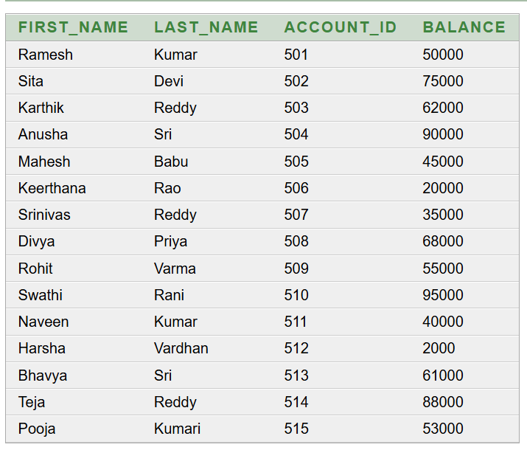

Q13. Display transaction details along with customer names
select c.first_name, c.last_name, t.transaction_type, t.amount, t.transaction_date from customer c, account a ,transaction t
where c.customer_id = a.customer_id AND a.account_id = t.account_id;

Output: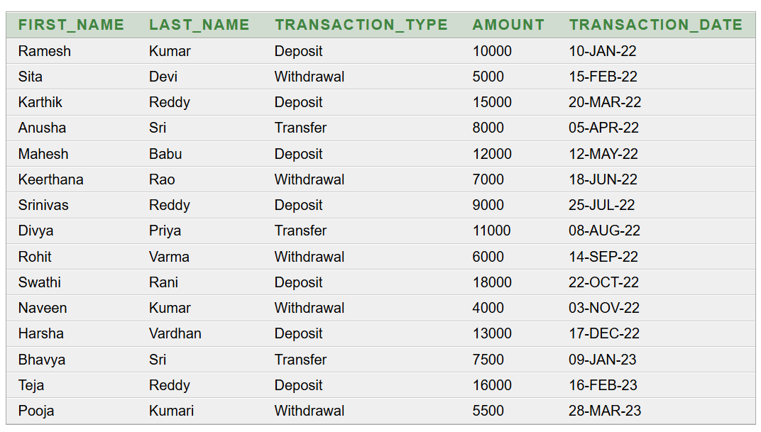

Q14. Find the number of accounts in each branch
select br.branch_name, count(a.account_id) as account_count from branch br, account a
where br.branch_id = a.branch_id
group by br.branch_name;
Output:

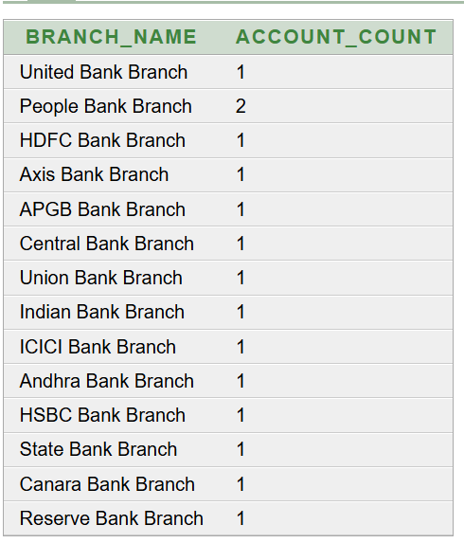
Q15. Find loan types whose average loan amount is greater than 300000
select loan_type, avg(loan_amount) as average_loan_amount from loan
group by loan_type
having avg(loan_amount) > 300000;
output:
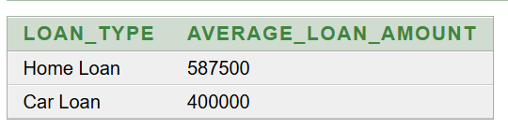
11. CONCLUSION
The Bank Account Management System provides a structured relational database solution for managing important banking information. The design organizes customers, accounts, transactions, branches, employees, loans, and related account information into connected tables using primary keys and foreign keys.
The database design helps reduce data redundancy and maintain data consistency through appropriate constraints and normalization up to Third Normal Form (3NF). The SQL implementation supports data creation, insertion, retrieval, updating, and transaction-related operations. Overall, the project provides a suitable database foundation for managing banking information efficiently and can be extended with additional banking services in the future.
.

12. FUTURE ENHANCEMENTS
- Online Banking – Provide secure online access for customers to manage their accounts.
- Fund Transfer – Support transfers between accounts and other bank accounts.
- ATM Integration – Connect the system with ATM services for withdrawals, deposits, and balance enquiries.
- Mobile Banking – Extend the system with a mobile application for convenient account access.
- Advanced Reports and Analytics – Provide detailed transaction, account, and customer reports.
- Backup, Recovery, and Enhanced Security – Improve data protection through stronger security, audit logging, backup, and recovery mechanisms.
REFERENCES
- Korth, H. F., Silberschatz, A., and Sudarshan, S., Database System Concepts, McGraw Hill.
- Elmasri, R. and Navathe, S. B., Fundamentals of Database Systems, Pearson.
- Oracle Corporation, Oracle Database SQL Language Reference, Oracle Documentation.
- Oracle Corporation, Oracle Database Concepts, Oracle Documentation.
- Coronel, C. and Morris, S., Database Systems: Design, Implementation, & Management, Cengage Learning.

